CSE220: Data Structures (Lab)

Fall 2024

Lab Quiz - 07

Duration: 30 Minutes

| Name: | ID: | Section: |
| --- | --- | --- |

### **Question 1 [15 Points]**

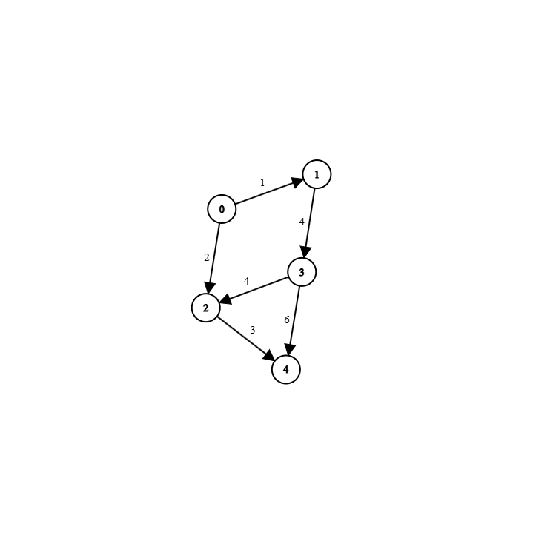

| Sample Input | 5, graph | Number of Vertices, The Graph |
| --- | --- | --- |
| Sample Output | 3, | Answer Vertex Index.  This Vertex 3 has the **most Outgoing edges;** for the **same reason, Vertex 0** can also be the **answer.** |
|  | [0,6] | Array of Outgoing edges.   Here, **outgoing edge 4!>5** which is why the Array has **0** in that place and **outgoing edge 6>5** so, that weight is added. As **vertex 0 can also be the answer** the resulting array for that would be **[0,0]**. |

For this **directed**, **edge-weighted** graph implemented using an **adjacency list**, find the vertex with the most **outgoing edges**. The vertex must have **at least 2** outgoing edges; otherwise, **return -1** (for Java an Empty array). After finding the vertex, **return** an array of all the **outgoing edges** from that vertex that have a weight **greater than 5**.

[Assume **Node** and **Graph** classes have been **implemented** but, you **cannot** use **Adjacency Matrix.** Here, the graph]